Identity Microservice

# Current Security Schema



***Framework***: *ASP.NET Identity*

***Dependencies***:

1. ***AspNetUsers Table:***
   1. dbo.AccountPendingEntries
   2. dbo.Agreements
   3. dbo.ApiApplications
   4. dbo.Applications
   5. dbo.ArchiveLoginIPs
   6. dbo.AspNetUserClaims ***(Asp Net Identity Framework)***
   7. dbo.AspNetUserLogins ***(Asp Net Identity Framework)***
   8. dbo.AspUserRoles ***(Asp Net Identity Framework)***
   9. dbo.AspNetUsers ***(Asp Net Identity Framework)***
   10. dbo.Audits
   11. dbo.AutoReports
   12. dbo.CorrespondenceHistory
   13. dbo.DecisionRuleRuns
   14. dbo.DripContentMetrics
   15. dbo.GiactResults
   16. dbo.InvoicePayments
   17. dbo.LexisNexisInstanceIds
   18. dbo.MessageRetailerusers
   19. dbo.Nurtures
   20. dbo.PaymentMethods
   21. dbo.RetailerUserInformationHistory
   22. dbo.SystemPeeps
   23. dbo.UserConcent
   24. dbo.UserConcentHistories
   25. dbo.UserDOBs
   26. dbo.UserHistories
   27. dbo.UserInfoes
   28. UserSSNs
   29. dbo.UserUsernames
   30. dbo.Vendors
2. ***AspNetUserRoles Table:***
   1. dbo.AspNetUsers ***(Asp Net Identity Framework)***
   2. dbo.AspNetRoles ***(Asp Net Identity Framework)***
3. ***AspNetUserRoles Table:***
   1. dbo.AspNetUsers ***(Asp Net Identity Framework)***
4. ***AspNetUserClaims Table:***
   1. dbo.AspNetUsers ***(Asp Net Identity Framework)***
5. ***AspNetRoles***
   1. Dbo.AspNetRoles ***(Asp Net Identity Framework)***

# Identity Micro Service

The Identity Micro Service responsibility will be to:

* *Authenticate Users (Using User/Password Grant Type).*
* *Provide Tokens to access* ***service-to-service*** *communication.*
* *Provide Token to access web application (****Json Web Token JWT****).*
* *Manage Scopes*
* *Manage Users*
* *Manage Resources*

# Terminology

* ***Scope***: A scope is an identifier for one or more endpoints that we want to protect. When a micro service wants to call any of those endpoints it first needs permission to do so. That permission if given in the form of token containing the scope.
* ***Access Token***: An access token is a signed object that is used to allow access to resources. A micro service can request an access token for a given scope from the Identity Microservice. If the Identity Microservice will allow the Microservice to access the scope it returns an access token that can be passed along with requests to the endpoints the scope is for.
* ***Claims***: Claims are key-value pairs used to provide information about an authenticated end-user or microservices.
* ***Identity Server***: It is an open source product which makes it easy to implement single sign on and access control in web application and HTTP APIs. This will play the role of Identity Microservice.

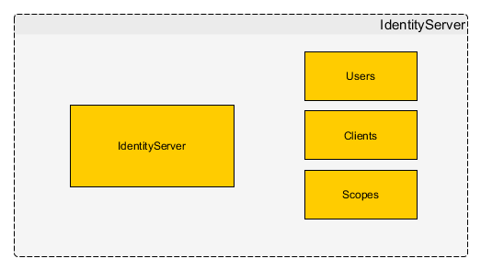

Packages required building Identity Microservice:

* ***IdentityServer4****: Its used in Identity Microservice for configure everything.*
* ***IdentityServer4.AccessTokenValidation****: Its used in clients to validate incoming request tokens if they contains* ***[authorize]*** *attribute by doing introspection.*

***Product Documentation:***[*http://docs.identityserver.io/en/release/*](http://docs.identityserver.io/en/release/)

***[Review Microservice-to-Microservice Security Sample.doc for a live sample]***